

FORECAST OF A FLOOD LEVEL IN A RIVER
A PROJECT REPORT

Submitted by
K. MANOHITH 20221CSE0199
V. SIVANANDA REDDY 20221CSE0245
P. SREEDHAR RAO 20221CSE0221

Under the guidance of,
Dr. Vijaya Kumar A V

BACHELOR OF TECHNOLOGY

IN

COMPUTER SCIENCE AND ENGINEERING

PRESIDENCY UNIVERSITY BENGALURU
DECEMBER 2025

PRESIDENCY SCHOOL OF COMPUTER SCIENCE AND ENGINEERING
BONAFIDE CERTIFICATE

Certified that this report “Forecast of a flood level in a river” is a bonafide work of “K. MANOHITH (20221CSE0199),V.SIVANANDAREDDY(20221CSE0245),P.SREEDHARRAO(20221CSE0221)”, who have successfully carried out the project work and submitted the report for partial fulfillment of the requirements for the award of the degree of BACHELOR OF TECHNOLOGY in COMPUTER SCIENCE ENGINEERING during 2025-26.

Dr. Vijaya kumar A V  Project Guide PSCS  Presidency University | Mr. Muthuraju V  Program Project Coordinator  PSCS  Presidency University | Dr. Sampath A K Dr. Geetha A School Project Coordinators PSCS  Presidency University | Dr. Blessed Prince Head of the Department PSCS  Presidency University

Dr. Shakkeera L Associate Dean PSCS
Presidency University

Dr. Duraipandian N
Dean
PSCS & PSIS
Presidency University

Examiners

Sl. no. | Name | Signature | Date
1 | Dr. Sharmasth Vali Y
2 | Mr. Sriram Parabrahmachari

PRESIDENCY UNIVERSITY

PRESIDENCY SCHOOL OF COMPUTER SCIENCE AND ENGINEERING

DECLARATION

We the students of final year B. Tech in COMPUTER SCIENCE ENGINEERING at Presidency University, Bengaluru, named K. MANOHITH, V. SIVANANDAREDDY, P. SREEDHAR RAO, hereby declare that the project work titled “FORECAST OF A FLOOD LEVEL IN A RIVER” has been independently carried out by us and submitted in partial fulfillment for the award of the degree of B. Tech in COMPUTER SCIENCE ENGINEERING during the academic year of 2025-26. Further, the matter embodied in the project has not been submitted previously by anybody for the award of any Degree or Diploma to any other institution.

K. Manohith | USN: 20221CSE0199
V. Sivananda Reddy | USN: 20221CSE0245
P. Sreedhar Rao | USN: 20221CSE0221

PLACE: BENGALURU DATE: 03-12-2025

ACKNOWLEDGEMENT

For completing this project work, we have received the support and the guidance from many people whom I would like to mention with deep sense of gratitude and indebtedness. We extend our gratitude to our beloved Chancellor, Pro-Vice Chancellor, and Registrar for their support and encouragement in completion of the project.
I would like to sincerely thank my internal guide Dr. Vijaya Kumar A V, Professor, Presidency School of Computer Science and Engineering, Presidency University, for his/her moral support, motivation, timely guidance and encouragement provided to us during the period of our project work.
I am also thankful to Dr. Blessed Prince, Professor, Head of the Department, Presidency School of Computer Science and Engineering Presidency University, for his mentorship and encouragement.
We express our cordial thanks to Dr. Duraipandian N, Dean PSCS & PSIS, Dr. Shakkeera L, Associate Dean, Presidency School of computer Science and Engineering and the Management of Presidency University for providing the required facilities and intellectually stimulating environment that aided in the completion of my project work.
We are grateful to Dr. Sampath A K, and Dr. Geetha A, PSCS Project Coordinators, Mr. Muthuraju V, Program Project Coordinator, Presidency School of Computer Science and Engineering, or facilitating problem statements, coordinating reviews, monitoring progress, and providing their valuable support and guidance.
We are also grateful to Teaching and Non-Teaching staff of Presidency School of Computer Science and Engineering and also staff from other departments who have extended their valuable help and cooperation.

K. MANOHITH
V. SIVANANDA REDDY
P. SREEDHAR RAO

Abstract
Floods are one of the most common and destructive natural disasters that severely affect human lives and infrastructures, and lead to a number of catastrophic consequences on the economics of the communities and the areas in question. In fact, the early warning and disaster preparedness is dependent on proper and timely monitoring of the rising water. The present project is focused on the design and development of an IoT-based flood level forecasting system that will allow real-time tracking of the water level in the river with the help of the relatively inexpensive sensors and communication modules.
The main element of this system is the ESP32 microcontroller where all the calculations are centralized. The module has an ultrasonic sensor (HC-SR04) which is utilised in the continuous mode to measure the distance between the sensor and the surface of the water. Based on the measured distance, the system computes the level of the risk of flood, and categorizes it into three levels, namely, No Flood Detected, Flood About to Be Detected, and Flood Detected. The various phases of the flood lead to various degrees of response:
The present position of the flood is presented on 16 x 2 I2C LCD and the distance that has been measured, and red and green LEDs are employed to indicate that conditions are safe or dangerous. A buzzer can also be employed to issue a verbal warning in case of a possible or actual situation of flood. The system is also characterized by automatic SMS notifications through SIM900A GSM module which are activated when the water level exceeds the danger points. Furthermore, all the information related to the water level is concurrently kept on ThingSpeak cloud service so that one can conveniently access, analyze, and visualize the statistics at any point.
Such system can be local alerted and remotely aware, therefore, making this system ideal to be deployed in such regions as rural or flood prone ones. A combination of the hardware devices and the wireless communication and cloud technologies make the project a scalable, cost-effective, and efficient tool of flood level prediction and early warning.
The proposed system will become a significant assistance in reducing the risks of disasters, thereby facilitating the evacuation and mobilizing of resources in time, which will at some point facilitate the mitigation of the possible damages and enhance the safety of the population. It is a good example of how IoT technology can be applied in addressing environmental issues and is also a step towards creating smarter and more resilient communities
Table of Content

Sl. No. | Title | Page No.
 | Declaration | iii
 | Acknowledgement | iv
 | Abstract | v
 | List of Figures | viii
 | List of Tables | ix
 | Abbreviations | x
1. | Introduction  - Problem Statement  - Objectives  - Need of the project  - Overview of the System | 1  2  2-3  3  4-5
2. | Literature review | 6-8
3. | Methodology | 9-12
4. | Project management  - Project timeline  - Roles and Responsibilities of Teams  - Risk Management  - Resource Allocation | 13  14  14  15
5. | Analysis and Design  - Flow Chart  - Block Diagram  - Circuit Diagram | 16-17  18-19  19-22
6. | Software and Simulation  - Arduino IDE  - ThingSpeak IoT Platform  - Libraries Used | 23  23-24  24
7. | Results and Testing  - Overview  - Preliminary Setup and Components Testing  - Simulated Water Level Functional Testing  - Output LCD and ThingSpeak Check  - GSM Alert Testing  - System Stability and Reliability | 25  25  25-26  26  26  26-27
8. | Applications  - Overview  - Flood Disaster and Early Warning Management  - Flood Control and Drainage Monitoring in Urban areas.  - Water Resource and Reservoir Management.  - Agricultural Flood Alert  - Environmental Monitoring and Research  - Remote and Rural Area Monitoring  - Smart City Integration  - Infrastructure Safety  - Disaster Response and Management  - Public Awareness and Community Engagement | 28  28  28  28  28-29  29  29  29  29  29  30
9. | Future Scope and Improvements  - Future Scope  - Possible Improvements | 31  31-32
10. | Conclusion  - Overall Conclusion  - Advantages  - Limitations | 33  33-34  34-35
 | References | 36-37
 | Base Paper
 | Appendix

List of Figures

Figure | Caption | Page
Fig.1.1 | Sustainable Development Goals | 5
Fig. 3.1 | The V-Model methodology | 10
Fig 4.1 | Development Process Gantt Chart | 13
Fig 5.1 | Flow Chart | 16
Fig 5.2 | Block Diagram | 18
Fig 5.3 | Circuit Diagram | 19
Fig 7.1 | Hardware Implementation | 27

List of Tables

Table | Caption | Page
Table 3.1 | System Design | 9
Table 4.1 | Project Timeline | 13
Table 4.2 | Roles and Responsibilities | 14
Table 4.3 | Risk Management | 14
Table 6.3 | Libraries Used | 24

Abbreviations

Abbreviation | Full Form
AI | Artificial Intelligence
AT | Attention (GSM AT command)
DC | Direct Current
ESP32 | Espressif 32-bit Wi-Fi/Bluetooth Microcontroller
GPIO | General Purpose Input Output
GSM | Global System for Mobile Communication
GPRS | General Packet Radio Service
GDU | GPRS Data Unit
HC-SR04 | Ultrasonic Distance Sensor HC SR04
ICDABI | International Conference on Data Analytics in Business and Industry
ICACCS | International Conference on Advanced Computing and Communication Systems
ICICT | International Conference on Inventive Computation Technologies
ICISS | International Conference on Intelligent Sustainable Systems
ICKECS | International Conference on Knowledge Engineering and Communication Systems
ICEMPS | International Conference on E mobility, Power Control and Smart Systems
IoT | Internet of Things
LCD | Liquid Crystal Display
LED | Light Emitting Diode
LSTM | Long Short Term Memory
ML | Machine Learning
NE | North Eastern Region of India
SMS | Short Message Service
UART | Universal Asynchronous Receiver Transmitter
Wi-Fi | Wireless Fidelity

Chapter 1

Introduction

Floods are one of the biggest natural disasters in nature affecting the lives of human beings and causing deaths of millions of people all over the world annually. They devastate the built environment, the agricultural sector and nature besides resulting in loss of lives. The water levels are often not communicated properly, therefore, leading to the delayed response in the flood cases and, thus, as a result, the escalation of losses.

The flood monitoring systems that are being used traditionally are based on manual processes that are expensive and normally need a centralized infrastructure; in this regard, they cannot be effective in remote or less developed regions. Through technological innovation in the field of IoT, we are now in a position to enjoy affordable, real time, and automated flood monitoring and warning systems that can guarantee the safety of people in the flood prone areas.

The following research titled Forecast of Flood Levels in a River using ESP32 and IoT is a brilliant example of how an intelligent water monitoring and emergency alerts system may be created and deployed. In essence, an ultrasonic sensor measures water level of a river or a lake. The sensor data is converted into a decision that should be made by an ESP32 microcontroller to categorize the situation into varying degrees of risks and each of these degrees is associated with a specific range of predefined distances. Thus, the system is able to provide audio and visual notifications to the target individuals by using LEDs and a buzzer. In addition to this, the alert messages can be presented on an LCD screen as well.

To deliver the information to people even in a situation when they are not physically present in the area, this project utilizes the Wi-Fi-based cloud communication through the ThingSpeak platform.

Further, when the water level reaches the stage where it is indeed hazardous or a matter of few steps, the users ought to get the information in the form of SMS which is carried by the SIM900A GSM module. In this way, the news will be communicated to the customers even in the absence of the Internet connection.

This flood warning system is not the end but the overall goal is to have a capability of foretelling the rise of water levels at least before they occur so that individuals and government officials can have sufficient time to undertake preventive measures. The system is inexpensive, reliable and

can be stretched making it applicable in both the large cities and the villages. It will be of immense importance especially in third world countries where it is recorded that the demand of such cheap flood-monitoring solutions like this is imminent.

Problem Statement
It is the main aim of the proposal to design and deploy a real-time IoT-based river level monitoring system having an automatically flood level forecasting and alert system. In addition to it, the project would like to provide a cheap, automated and growing product that includes an ESP32 microcontroller, an ultrasonic sensor, and a wireless communication module to achieve the following functions:

- Water level in a river or water body Periodically monitor water level in a river or water body.
- Determine degree of risk because of flood based on the water level standards.
- Allow local alarms by use of LED indicators, buzzer and LCD display.
- Send a SMS notification via a SIM 900A GSM to the authority or an individual.
- Visualize and access real time data on ThingSpeak cloud platform remotely.
- The rationale of the device is to offer persuading early warning systems in flood prone places, assist the decision-making process and ultimately reduce the issue of floods both as far as losses and risk are concerned.
1.2 Objectives
The key goals of this project are:
- To develop a system that monitors the level of the river 24/7 with the help of an ultrasonic distance sensor (HC-SR04) mounted on the riverbank or over the water surface.
- To apply the idea of risk of flooding, which will be split into three categories and these are No Flood Detected, Flood about to be Detected, and Flood Detected which will be identified basing on the water level thresholds, which are measured.
- To provide the local people with the on-site information about the events or water level alterations by immediate notifications with:
- 16x2 I2C LCD display that might be utilized to display the realtime status and water level.

- Buzzer can be installed to give auditory warnings when there is risk of flooding.

- To utilize a SIM900A GSM module to send remote SMS notifications whenever the water level reaches the warning or danger threshold to ensure that the individual receiving the notification receives the notification even in the case that the person is not connected to the internet.
- To communicate with ThingSpeak IoT platform where the water level data will be uploaded to access the remote data, analyze historical data, and visualize the trends with the help of the ESP32 internal Wi-Fi network.
- To manage the conditions when this same message is delivered to the person more than once and to do it rationally by making decisions that SMS messages are to be delivered once and once only within one event level and this helps to avoid flooding with messages and secure effective communication.
- In a bid to come up with a reliable, battery-powered and easily portable gadget that can be utilized in the rural or remote regions or less-developed regions where floods are a constant threat.
- To utilize the embedded systems and IoT technology as useful resources to enable disaster preparedness and environmental monitoring.
1.3 Need for the Project
Floods: Floods present a great threat to human lives, properties, agriculture, as well as vital infrastructures, primarily in the regions that the rains are erratic or where the disaster management facilities are not of the standard. In most cases, floodwater level monitoring through manual means is a non-continuous and slow process, which is inefficient. However, in most cases, the individuals have very limited time to respond, evacuate, or implement safety measures as a result of late warnings, which causes massive socio-economic losses. Therefore, an automatic tool to predict the level of floods caused by the increase of river water is very desirable. The connection of the system with the IoT technology, wireless communication, and cloud-based data tracking does not only make it more accurate but also provides that the alerts are provided in time and that the planning and preparedness can be assisted better. Through this breakthrough in the disaster management, the authorities and risk-prone communities are able to be mobile and consequently significantly reduce the risk of harm and allow the effective management of the emergencies.

1.4 Overview of the System
The central theme of the system, "Forecast of Flood Levels in a River Using ESP32 and IoT," is how a case such as this one can be prevented when a flood sensor is capable of giving real-time water level data in rivers or other water bodies. In principle, a system includes built-in hardware, wireless communication devices, and cloud-based data storage to offer a technically automated and comfortable system to people living in remote or flood-prone zones.
The operations that practically belong to the ESP32, the microcontroller, which is the most significant component of the system, are processing and communication. The ultrasonic sensor (HC-SR04) is utilized in order to scan the surface of the river. The closer the water is to the sensor, the higher the sensor computes the distance between them in a fast and simple manner. Depending on the distance measured, the system decides which scenario occurred; Normal, Warning, and Flood Detected.
The following real-time status dissemination will be used to raise local utilization of the system:
- Status and water level I2C LCD display 16x2.
- Normal and danger indicators which are LED.
- A buzzer alarm function in a state of warning and flood.
Also, the technologies of the dual alert system and data transmission applied in this project allow the long-distance monitoring and easy access to data. The ThingSpeak cloud platform uploads the ESP32, real time data, a location, at which the users can provide graphics on the data measured and records stored at any time and location anywhere using any internet connected device. More than this, in case it is not a critical threshold of a warning or water increase, the system will automatically send texts via a SIM900A GSM module. Therefore, the authorities and residents can be as close to the threat as possible and take immediate action even in cases when the Internet connection is not available.
The system is independent and continuous and therefore requires very low human input in running the system. By integrating the local announcement features, web based illustrations, and GSM messaging features such technology can easily be made available in the rural regions, along the banks of the rivers, in the agricultural fields, along dam outlet, and in the drainage systems in the city.

In conclusion, it is an effective, scalable and affordable technological idea and therefore, it is indeed capable of alleviating the huge issues such as disaster preparedness and risk of floods. Due to the consumption of the IoT and embedded electronics, it is thus time-saving, it enhances the safety of individuals, and it eases the task of minimizing the losses occurring during floods.
Fig 1.1 Sustainable development goals

Chapter 2

Literature review

1. K. Mahato, P. Sarma, and P. Barman, "An IoT based real time Flood and Weather Monitoring system," 2024 IEEE Calcutta Conference (CALCON), Kolkata, India, 2024, pp. 1-5, doi: 10.1109/CALCON63337.2024.10914313.

As the monsoon repeats itself yearly, a big portion of the Indian population is being flooded away. The geo-morphological character of the Brahmaputra and Barak Valleys exposes the North-Eastern (NE) region of India to excessive floods to a significant degree. However, the flood forecast systems which are operational in India still remain immature and cannot of any long term benefit to the country. Even though the ensemble prediction technique of precipitation forecast has achieved a lot in its progress, improvements should be done on the systems. This paper suggested an IoT based weather, and climate forecast system on ESP8266 and different sensors to monitor data in real-time, assimilate data and predict a weather mechanism that ensures the predictability of occurrence of flooding in a particular area. The system has been experimented with and proved successfully in the NE part of India and the findings provide evidence of reliability and cheapness of the system.

2. B.P.P.Kumar, S. S. Hari Gokul, A. Gow and L. Adarsh, Remote Monitoring of Water Level of Bridges and Flood Zones, 2025 International Conference on Knowledge Engineering and Communication Systems (ICKECS), Chikballapur, India, 2025, pp. 1-6, doi: 10.1109/ICKECS65700.2025.1103584.

Flooding of bridges and low grounds can pose a risk to the infrastructure as well as human beings so to address this issue a remote water level monitor system will be designed using a NodeMCU ESP8266, ultrasonic sensor relay module, and other necessary materials. The proposed system is real time measure device with visual indications to high water levels in form of LCD screens and LEDs. The safety operation is based on the relay module to start, and the NodeMCU is the messenger, which transmits the data to the authorities.

It is a fairly inexpensive and expandable way of addressing the issue of commonly flooded locations which are quite distant in terms of ensuring that disasters are managed safely and that individuals are ready to face them. The fact that the components can be deployed and maintained easily therefore leads to the implementation of the smart city concept.

3. S. Sindhuja and V. Sravanthi, IoT Based Flood Monitoring and Alerting System in Smart Cities, 2024 1 st International Conference on Innovative Sustainable Technologies in Energy, Mechatronics and Smart Systems (ISTEMS), Dehradun, India, 2024, p. 1-4, doi: 10.1109/ISTEMS60181.2024.10560215.

Flooding is a natural disaster which is quite damaging and may take place in any part of the world. In order to observe the flooding in Nakhon Si Thammarat, a southern Thai province, the local government resolved to ensure that the water level, flow, and rainfall are monitored at the most inaccessible locations. The primary goals of the created system are to deliver the flood information to the population that requires such information to be able to prepare themselves and be used as a medium to exchange the information on the flood between the authorities involved in the problem and the professionals to improve their activities and collaboration. The system that has been created comprises of a sensor network, a processing/transmission unit, and a database/application server. They are on-site information of water status that can be distant checked through a wireless sensor network forwarding to the application server through mobile General Packet Radio Service (GPRS). VirtualCOM is a middleware that we created in order to establish the communication between the application server and the remote sensors connected to a GPRS data unit (GDU). The GDU becomes similar to a real cable when connected to VirtualCOM to connect the remote sensors to the application server. The application server will be a web based application that is configured on MySQL as relational database, PHP and JAVA as web applications. Using a web browser or WLAN, users may access updated information about the situation with water and even be able to predict such situations. The intended system proved that there was possibility of real-time water monitoring with the use of modern sensors using a wireless connection.

4. S. Gunanandhini, L. M, M. R. R, P. K. S and N. K. V, Forecasting and Real Time Flood Monitoring System using IoT, 2024 10 th International Conference on Advanced Computing and Communication Systems (ICACCS), Coimbatore, India, 2024, pp. 1228-1233, doi:10.1109/ICACCS60874.2024.10716883

This study suggests an IoT system that is solar-powered to gather hydrological information about rivers such as water discharge and temperature. The model, along with that, retrieves atmospheric data, like the moisture content and wind speed. Another factor noted in the paper is that the emergence of climate change associated uncertainty and resultant natural disasters has rendered the measurement of precipitation in the geological region challenging. In order to rise above such challenges, real time flood monitoring and forecasting system has been implemented. The data collected is analyzed by using the long short-term memory (LSTM) model, this model is used in machine interpretation and time series prediction. The model offers the flood events to categories of no precaution, yellow caution, orange warning and high alert. The mobile app called Floodwall protection can be used to obtain the data of data collection, which serves to relay the information about the alerts to the general population and the emergency management team through SMS. The system forecasts the floods with precaution being 95 percent, yellow warning being 97 percent, orange warning being 96 percent and the High alert being 98 percent.

5. P. Chitra, K. Acharjya, V. Ojha, P. Das, A. Faiz and S. B. Rao, "IOT and Sensor-Based Flood Monitoring and Warning Systems based on disaster management," 2025 International Conference on Automation and Computation (AUTOCOM), Dehradun, India, 2025, pp. 471-476, doi: 10.1109/AUTOCOM64127.2025.109566

The latest example of the use of such technologies in disaster management is the Internet of Things that contains sensors to measure and report the flooding and alert users. Through the interconnected devices and sensors, the systems are able to receive real-time information on the water levels, weather condition and other environmental conditions that result in a flood. The knowledge will help make more precise predictions and warnings about flooding and thus help the communities be more prepared to the large-scale weather events as well as have a better idea of when the disaster can occur.

The benefits of IOT and sensor-based flood monitoring systems include:

Sensor cadmium selenium photocells, sharp water sensors, infrared sensors, and water level sensors, rain gauges, and temperature sensors where it is subject to floods. This they achieve by installing sensors spread all over the city which will be able to detect the amount of water or rainfall and even report back to a central box. The data is then processed by sophisticated algorithms that generate forecasts and alerts of floods using the web-based platforms or mobile applications. The primary merit of such systems is the real-time flood information with precise outcomes that also facilitate evacuation and other disaster management processes, within communities. Moreover, these systems can also be incorporated with the already existing emergency response systems, which serve as information providers of graduate disaster management. The IOT-based flood monitoring systems, and the sensors are also great innovative tools to disaster management that will raise awareness, thereby resulting to improved preparedness and reduced time of response after the natural disasters such as flood have taken place and the communities concerned.

Chapter 3

Methodology

Overview
The methodology contains the step-by-step approach to the design, development, and testing of the IoT-based flood level forecasting system based on ESP32, ultrasonic sensor, GSM alerts and cloud integration. The development process was performed in four key steps as follows: system design, hardware implementation, software development and testing and evaluation. Formal development was performed using an Agile-based V-Model and where:
1. System Design
The process of development has started by determining the requirements of the system and conceptualizing the working architecture of the flood monitoring system. Data flow, sensing mechanism, decision logic, and alert communication were represented in a block diagram and a flowchart.
The design focused on:
- Quality real time water level detection.
- Multi-stage categorization of hazards.
- Dual system (IoT+ GSM).
- In-store and remote alarm systems.
- Long-term autonomous and power-saving performance.
Categories of floods were established as:
Distance Measured from Sensor | System Status | Action Triggered
>100 cm | No Flood | Green LED ON, No Alert
50–100 cm | Warning | LCD + SMS Alert + Buzzer
<50 cm | Flood Detected | Continuous Buzzer + Critical SMS
Table 3.1

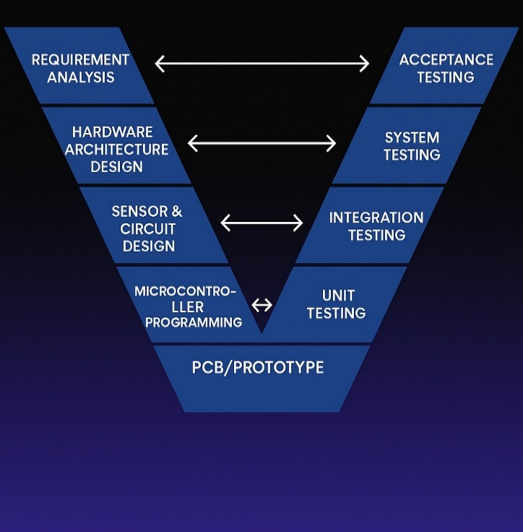
Fig. 3.1 The V-Model methodology
2. Hardware Implementation
Once the system design was finalised, the circuit diagram was followed in assembling the components.
The key steps included:
- Mounting of the HC-SR04 ultrasonic sensor: The ultrasonic sensor is to be mounted on a surface that is above the simulated water surface.
- Linking the processing unit ESP32 microcontroller.
- Metadata(output devices- LCD, buzzer, LEDs) output Interface using GPIO pins.
- Relating the SIM900A GSM module with ESP32 by means of UART communication.
- Environment: ESP32 is connected to a stable Wi-Fi network and uploaded to ThingSpeak cloud in order to upload data.
- All components had to be on a common ground.
- To prevent the brown-outs, then the GSM component should be supplied with an independent 12V power supply.
- A prototype of a breadboard was then constructed, wire management and stabilization was made to ensure prolonged operation.

3. Software Development
The system firmware was written on Arduino IDE with the corresponding sensors control, LCD display, GSM communication, and ThingSpeak cloud integration libraries.
The fundamental programming code consisted of:
- Initialization phase
- Configure I/O pins
- Initialize GSM, LCD, and Wi-Fi
- Connect to ThingSpeak server
- Connect to ThingSpeak server
- Continuous Monitoring Loop
- Read distance of ultrasonic sensor.
- Use the filtering logic in order to eliminate noise.
- Compare values to predetermined values.
- Response and Decision Implementation
- LEDs indicating the triggers, buzzer and LCD update status.
- Send a data collection to ThingSpeak on a regular basis.
- Send SMS Send SMS alert only on change (event flag system) of level.
- Failsafe Handling
- Auto reconnect Wi-Fi
- Re-attempt GSM network in case it is not available.
- Return system values on regaining safe condition.
Pseudo-logic used:
Start → Initialize → Read Sensor → Compare Threshold → Trigger Alerts → Upload Data → Repeat
4. Testing and Evaluation
System functionality was tested in the controlled simulated conditions in order to validate the testing.
4.1 Sensor Testing
Simulating of various measured distances was done by manually moving a reflecting surface beneath the sensor. A ruler and serial monitor were used to check the readings.
4.2 Alert Mechanism Testing
- LEDs turned on depending upon condition.
- The buzzer reacted appropriately when there was warning and danger.
4.3 GSM Communication Testing
A SIM card was loaded in to the GSM module and various SMS test commands were implemented to test the reliability of message delivery.
4.4 IoT Cloud Testing
Monitoring ThingSpeak graphs was done in real-time to ensure successful periodic data upload and visualization.
  - System Stability Testing
The system was tested over a few hours to test:
- Sensitivity of sensor values.
- Alert reliability
- Wi-Fi reconnection handling
- Power reset recovery
5. Data capturing and performance check.
All the outputs such as LCD readings, ThingSpeak records, SMS warnings and physical warnings were recorded and compared with manual simulated readings. The response time and the accuracy of the system were checked and concluded to match the expected outcomes.

Chapter 4

Project Management

Project Timeline
The project was conducted in a period of four months (July 2025 06 November 2025). The project was executed in a systematic process that started with the planning and research of the component, and then started with prototyping, software development, debugging, testing and the final documentation.
The Gantt chart was used to arrange activities and monitor weekly progress in order to complete all the milestones on time.The project guide was reviewed weekly to confirm the performance of the system and to make sure the milestones were met.

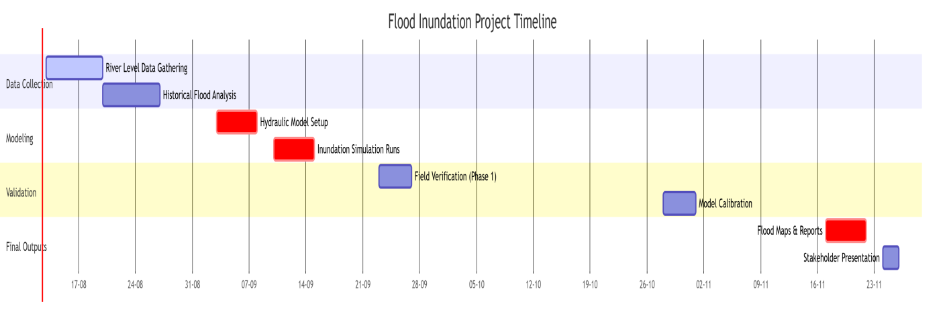
Fig 4.1 Development Process Gantt Chart
Month | Major Activities
July 2025 | Literature review, system planning, component selection, defining objectives
August 2025 | Procurement of ESP32, ultrasonic sensor, LCD module, GSM module; breadboard assembly; initial circuit testing
September 2025 | Coding for sensor integration, alert logic, ThingSpeak connectivity, GSM module testing
October 2025 | Full system integration, calibration of sensor thresholds, SMS alert tuning, cloud testing
November 2025 | Field simulation testing, improvements, project documentation, final demonstration
Table 4.1

  - Roles and Responsibilities of Teams
The project team operated as a team with different responsibilities being allocated on technical strengths so that the project could run smoothly.
The coordination was performed via WhatsApp coordination group and shared Google Drive folders.
Team Member | Role | Responsibilities
K. Manohith | Hardware Integration Lead | Interfaced ESP32 with ultrasonic sensor, GSM module, and LCD. Developed circuit layout and verified data acquisition accuracy.
P. Sreedhar Rao | Software & IoT Integration Lead | Developed firmware logic, ThingSpeak communication code, SMS alert logic, and LCD display handling.
V. Sivananda Reddy | Testing & Documentation Lead | Performed simulation tests, optimized sensor readings, verified SMS alert triggers, and compiled report and diagrams.
Table 4.2

Risk Management

The Risk evaluation was conducted at every stage of the development in order to avoid technical failures and reliability of the systems. Table below is a summarized list of key project risks and mitigation:
Risk | Impact | Mitigation Strategy
Sensor instability due to environmental noise (rain, wind, vibration) | Inaccurate readings or false alerts | Calibration, filtering logic in code, multiple sample averaging
GSM network failure | SMS alerts may not be delivered | Retry mechanism and fallback to cloud monitoring
Wi-Fi unavailability in remote areas | ThingSpeak logging failure | Independent GSM alert system ensures monitoring continuity
ESP32 power instability | Unexpected resets or data corruption | Stable regulated supply and dedicated power input for GSM module

Table 4.3

  - Resource Allocation
Resource management involved planning human resource, hardware parts, laboratory access, and software packages to implement the system.
Human Resources:
- Members of student project team.
- Project guide supervision
- Testing and safety with the help of laboratory technicians.
Hardware Resources
- ESP32 development board
- HC-SR04 Ultrasonic Sensor
- LCD 16×2 (I2C)
- GSM Module SIM900A
- LEDs, buzzer, jumper wires, breadboard.
- Power supply and multimeter
- Software Resources
- Arduino IDE
- ThingSpeak IoT platform
- AT command interface of GSM testing.
- Documentation (MS word, Canva/Visio to make diagrams)

The fifth step is Progress Monitoring and Communication.
- In order to organize the project correctly, the continuous monitoring system was adhered to.
- Meetings Weekly Review: A look at the progress made and adjustments made where necessary.
- Testing Logs: Logs of sensor measurements, network behavior, and behavior of the algorithm was kept.
- Version Control: Iterations of codes in a timely manner to be traced.
- Communication Channels.
- Google drive (common code, testing data, results, final documentation).
- This form of monitoring made the project run smoothly and achieve its goals within the scheduled time.

Overview
Chapter 5

Analysis and Design

The flowchart is the logical flow of the operations within the flood level monitoring and alert system. It describes the ESP32 microcontroller code of response to sensor data, decision-making, and activation of the right response according to the water level indicators.
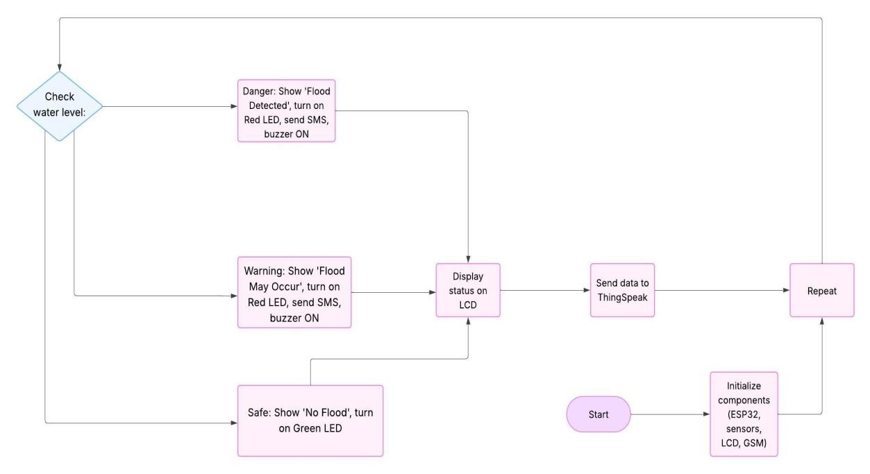
Fig 5.1: Flow Chart
5.1.2 Step-by-Step Explanation
1.Start
- The system will start working upon turn on.
- ESP32 puts up all required modules that include ultrasonic sensor, LCD display, GSM module, LEDs, and buzzer.
2.Initialize Components
- Setting up the pins, launching serial communication, connecting to Wi-Fi (to ThingSpeak), and preparing the LCD and GSM modules to be used are done by the microcontroller.

3.Measure Distance
- The ultrasonic sensor (HC-SR04) has the ability to measure the distance between the sensor and the water surface.
- The present water level is calculated based on the distance.
4.Evaluate Flood Condition
The distance obtained is compared with predetermined distances:
- Safe (No Flood): Distance > 100 cm
- Alarm to Be Found out (Flood Dominating).
- Distance 50 to 100 cm o Danger Distance less than 50 cm.
5.Take Appropriate Action
- Depending on the condition: o Safe: Green LED is ON, red LED and buzzer are OFF, no SMS is sent.
- Caution: Red LED ON, buzzer, SMS, sent on one occasion to alert user.
- Red LED and buzzer ON, SMS sent,once as emergency alert.
6.Display on LCD
The system displays the LCD with the up-to-date flood status on the first line (e.g., it can be no flood, flood warning, and flood detected), and the measured distance on the second line (e.g., it can be dist: 72.4 cm).
7.Send Data to ThingSpeak
- The ESP32 transmits the most recent reading of the water level data to ThingSpeak cloud platform via the Wi-Fi.
- This enables remote users to view the real time levels of floods and also analyze the past data.
8.Repeat
Once this is done, a short delay is applied and then the system returns to measure the next reading, and the system can be monitored continuously.

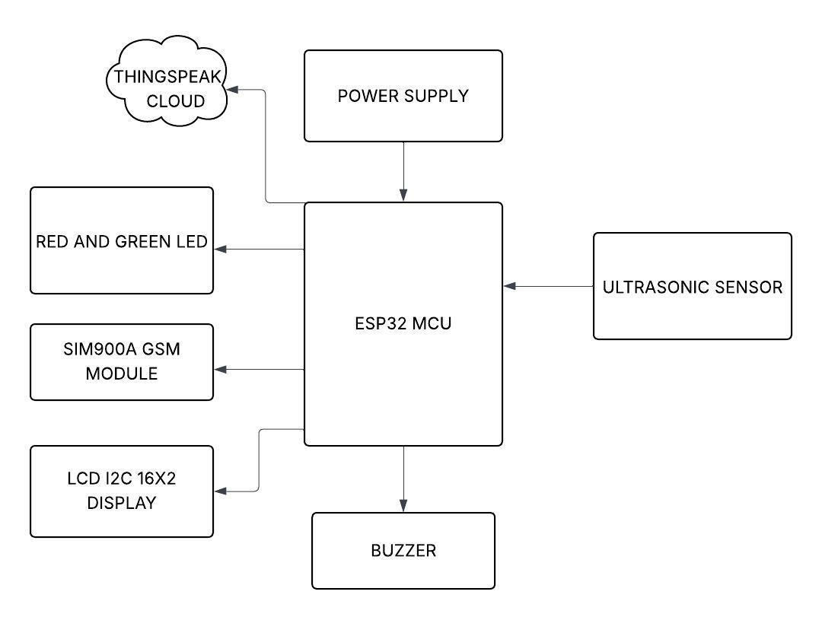

Fig5.2: Block Diagram
    - Block Description
1.Ultrasonic Sensor (HC-SR04)
- Placed over water (e.g. river or canal).
- Measures the distance between the water level and it.
- Gives service and takes credit.
- Transfers this value to the ESP32.
2.ESP32 Microcontroller
- Plays the role of brain of the system.
- Reads the distance value a constant number of times of the ultrasonic sensor.
- According to threshold levels, defines the state of the flood:
- No Flood Detected (> 100 cm) o Flood About to Be Detected (50300 cm) o Flood Detected (< 50 cm)
- Controls all outputs:
- Switches LEDs and buzzer. o shows messages on the LCD.
- Sends SMS alerts via GSM.
- Sends information to ThingSpeak through Wi-Fi.
3.LCD Display (16x2 with I2C)
- Displays two lines.
- Status (e.g., "Flood Detected") or no flood
- Line 1: Status (e.g., "Flood Detected"), no flood.
- Line 2:cm of water level (e.g., "Dist: 72.4cm")

4.LED Indicators (Red and Green)

Red LED lights up when danger flood level is observed.

Green LED is lit in normal conditions.

5.Buzzer

Switched on under warning or flood observed conditions.

Gives audible warning to people around.

6.GSM Module (SIM900A)

Alerts are SMSs which are sent to a registered mobile number when:

Flood will soon be tracked o Flood tracked.

The serial communication (UART) with ESP32 is used.

7.ThingSpeak Cloud platform of IoT.

Gets ESP32 real-time data on the water level via Wi-Fi.

Presents information in the form of graphs and dashboards.

Allows the users to check the water level anytime and anywhere.

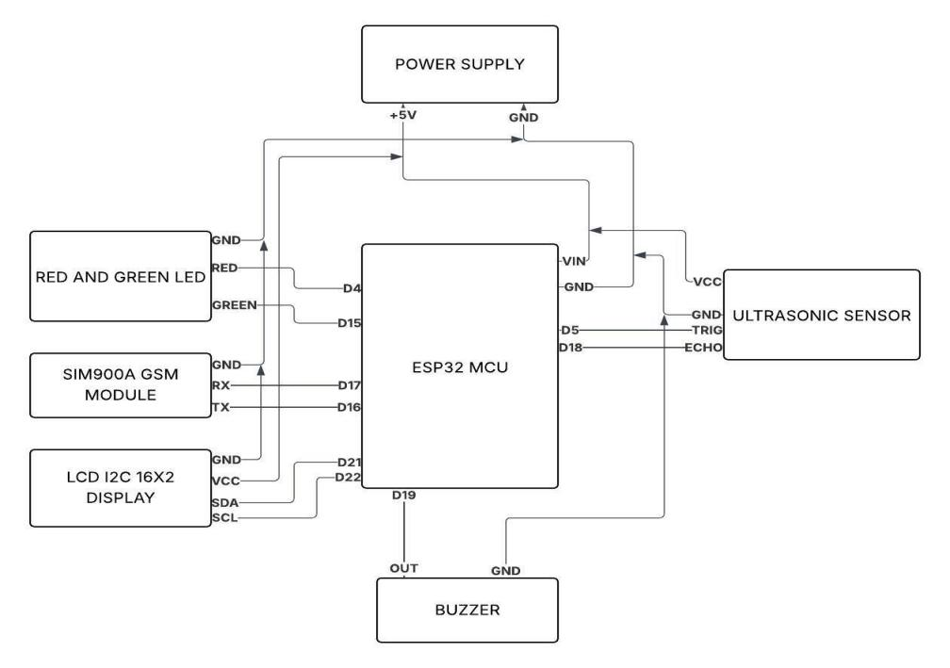
Fig5.3: Circuit Diagram

5.3.1 Overview
The circuit diagram is a diagram that shows the electrical connection and interface between the ESP32 microcontroller and the rest of the electrical components that are used in the flood level monitoring system. It shows how the power, the control and the communication with each sensor and output device are organized in order to achieve the required flood detection and alert functionality.

5.3.2 Major Strengths in the Circuit.
• ESP32 Development Board
• Ultrasonic Sensor (HC-SR04)
• SIM900A GSM Module
• 16x2 LCD Display with I2C Interface.
• Red LED (Flood Indicator)
• Green LED (Safe Indicator)
• Buzzer
• Supply (5V Esp32, 12V GSM Module)
The circuit connection in this case is illustrated through the following steps:
1.ESP32 Microcontroller
• usb powered (5V) or external-powered.
Contains 3.3 V to 5 V depending on the demand.
• Has GPIO pins, which are to be utilized to manage sensors, buzzer, LEDs, LCD and communicate with GSM module.
2.Ultrasonic Sensor (HC-SR04)
• VCC → 5V on ESP32
• GND → GND
• Trig → GPIO (e.g., D5 / GPIO18)
• GPIO to echo (where there is a voltage divider) with voltage divider (e.g. D18 / GPIO19)
3.LCD 16x2 (with I2C Module)
• VCC → 5V
• GND → GND
• SDA → GPIO21 (default I2C SDA on ESP32)
• SCL → GPIO22 (default I2C SCL on ESP32)
• Shows messages of water level and flood information.

4.Buzzer
• Positive terminal → GPIO (e.g. GPIO25)
• Negative terminal → GND
• Activated by digital HIGH/LOW so as to produce alarm sounds in case of flooding.
5.Red and Green LEDs
• Red LED (Flood):
o Anodeを GPIO (e.g. GPIO26) through 220O resistor.
o Cathode → GND
• Green LED (Safe):
o Anode to GPIO (e.g. GPIO27) with 220Ohm resistor.
o Cathode → GND
6.SIM900A GSM Module
• VCC → External 12V DC Adapter
• GND → Common GND with ESP32
• TX (GSM) → RX (ESP32 GPIO16)
• RX (GSM) → TX (ESP32 GPIO17)
7.Power Supply
• ESP32 powered via USB (5V)
• SIM900A operated on a different 12V adapter to avoid cases of brown-out.
• There exists common GND in all modules in order to operate in a proper circuit.

5.3.4 Explanation of Working
1.The ESP32 activates all modules when the system is switched on and is starting to read data on the ultrasonic sensor.
2.The distance to the water surface is measured and handled in ESP32 and checked against set values.
3.Based on the water level:
- The horizontal displays the status and distance in LCD. Green LED is activated when there are safe conditions.
- Red LED turns on when warning or danger.
4.In case the water level is within warning or danger zone ESP32 sends SMS using the SIM900A GSM module to the mobile number registered.
5.At the same time ESP32 is uploading the data on the distance and flood status to the ThingSpeak IoT platform using Wi-Fi.

5.3.5 Safety & Performance Notes
Level shifters or voltage dividers will be required at any point connecting 5V signals to the 3.3V logic in ESP32 (particularly GSM and ultrasonic Echo).

Chapter 6

Software and Simulation

The implementation of the Flood Forecasting and Monitoring System also used open-source software tools and cloud computing to code, manage, and visualise the behaviour of the system.
Given their support of embedded systems development, IoT connectivity, and data logging, these tools support them. The software environment was chosen with the consideration of being compatible with ESP32 microcontroller and also capable of running real-time operations.
6.1 Arduino IDE
- Purpose:
Was used to code and upload code to the ESP32 board.
- Features:
- C and C++ Supported user interfaces o Easy and user-friendly user interface.
- Big community support and offers open-source libraries.
- Serial Monitor to debug in real-time and
- sensor data verification
Version Used:
Arduino IDE 2.x (should be used in ESP32 development)
- Platform:
Works with Windows, MacOS and Linux.
- Project application: Wrote the primary firmware which reads sensor values, drives the output devices (LEDs, buzzer, LCD), transmits data to ThingSpeak and communicates with SIM900A GSM module.

6.2 ThingSpeak IoT Platform
Purpose:
A cloud based application to store, analyze and visualize sensor values of the ESP32 in real time.
Features:
- Real time graphs and dashboards o Public and private channel support o RESTful API support and integration with.
MATLAB
- Appropriate to the IoT and environmental monitoring apps.

Use in Project:
- ESP32 transmits data on water levels to ThingSpeak over Wi-Fi o Permits remote access to river levels and monitoring graphs and charts.
- Assists in flood prediction and trends analysis.
- Access: Available on any internet accessible computer through a browser.

6.3 Libraries Used
The code of the project used the following Arduino libraries to connect with the various modules and execute functions of the system:

Library Name | Purpose
WiFi.h | Connects the ESP32 to a Wi-Fi network
ThingSpeak.h | Sends sensor data to the ThingSpeak cloud platform
LiquidCrystal_I2C.h | Drives the 16x2 LCD via I2C communication

Chapter 7

Results and Testing

Overview
The Flood Level Forecasting and Monitoring System proposed was successfully assembled and programmed, and tested under a controlled and simulated environment. The system proved to be effective in terms of tracking water levels, categorizing the risk of floods, enabling the relevant alerts, and storing information on the cloud. The testing was done in stages to ensure that the work of each module and the system itself was functioning properly.

7.2 Preliminary Setup and Components Testing.
Full system tests were not conducted until individual tests on each of the hardware components were completed. The developed code was flashed into ESP32 Board in the Arduino IDE. The accuracy of the ultrasonic sensor was tested in measuring range by monitoring the output of the ultrasonic sensor in the Serial Monitor. The I2C LCD was also tested on proper communication and display output. In a similar manner, red and green LEDs were attached to ensure the proper responses of the GPS protocol. The buzzer was also tested to make sure it works when it is called upon. SIM900A GSM module was supplied independently by a 12V DC adapter and the AT commands were used to test the successful transmission of SMS. When all the components proved to be working as anticipated, they were installed into the entire system.

7.3 Simulated Water Level Functional Testing.
As it was not possible to test using a real river, different distances of the sensor with a flat object (symbolizing the water surface), were modeled in order to simulate different flood conditions.
At the distance of more than 100 cm when the object was put there, the system worked out the distance as a safe condition. The green LED was on, the red LED and the buzzer were not on, no SMS was sent and the LCD said No Flood with the required distance.
Initialisation of the system to a warning stage happened when the object was brought nearer to represent an increase in the height of water level between 50 cm and 100 cm. The red LED was switched on, the buzzer was switched on and off and a warning SMS was delivered with the help of SIM900A module. The LCD changed the status to "Flood Warning" and the distance that was currently being traveled. The ThingSpeak channel also interred the new reading in real-time.
At a distance less than 50 cm, the system detected that it was in a flood. The buzzer kept ON and flashed the red LED or kept showing it on and a second SMS alert was made with a message of Flood Detected. Again, the LCD reflected the correct value as it showed the presence of flood and updated the value in ThingSpeak over Wi-Fi.During the testing, the system was able to react to the change in the water level instantly, which demonstrated that it monitored the changes in real-time.

7.4 Output LCD and ThingSpeak Check.
The I2C LCD showed the current flood status on the first line with the distance measured on the second line. The screen was showing the notification of each new reading, and there was no noticeable delay or flickering of the screen. The ThingSpeak platform was also able to receive the ESP32 data. The data on water levels was then plotted in real-time on ThingSpeak dashboard, which gave a clear history of distance changes.

7.5 GSM Alert Testing
A valid SIM card and adequate supply of power were used to test the SIM900A GSM module. In the warning level as well as the danger level, the module was able to deliver the SMS alerts to the registered phone number. The system logic was used to minimize spam or repeated messages by ensuring one SMS was only delivered each time there was a change in condition unless the level of event changed. This made the communication effective without making the user receive redundant notifications.

7.6 System Stability and Reliability
The system was found to be stable by being tested on long durations. It would still operate successfully without resets and failures. Once the power was lost or manually reset, the ESP32 was automatically reinstated and returned to the usual operation. This ascertains the reliability of the system under field conditions where power fluctuation might exist.
Conclusion
The system completed all the required tests and worked correctly and consistently. It achieved all the project requirements: measuring water levels, categorizing risks of floods, sending warnings through SMS and the local pointers, and transmitting information to the cloud that would be used remotely. This proves the suitability of the system as a real time flood monitoring system that is effective to implement in a flood prone or rural environment with limited infrastructure.

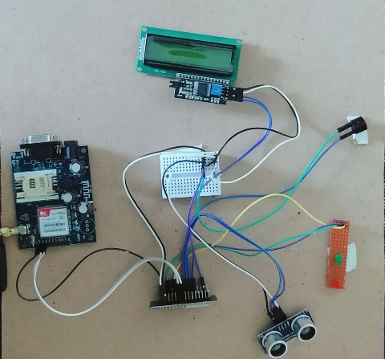

Fig 7.1 : Hardware Implementation

CHAPTER 8

APPLICATIONS

Overview

Flood Level Forecasting and Monitoring System, which has been developed with ESP32, ultrasonic sensor, GSM communication, and IoT, has a variety of practical applications in various spheres. Its capacity to offer real time review of the water level, early notifications, and remote data enables it to be a key element in flood disaster mitigation and water resource management. The major uses of the system include the following:

8.2 Flood Disaster and Early Warning Management.

Its main use is in order to give warning of the floods to people residing close to rivers, lakes, or other flood-prone regions. Early warning on the increasing water level will allow the authorities and citizens to carry out precautionary activities like evacuation hence reducing the loss of life and property.

8.3 Flood Control and Drainage Monitoring in Urban areas.

The system can be implemented in the cities to track the drainage systems and canals and storm water levels to assist the city planners and municipal corporate to control the urban areas.Can effectively overflow in times of heavy rain or storms.

8.4 Water Resource and Reservoir Management.

The system helps in water optimization, regulating overflow level and managing water distribution to the agricultural and industrial sector since water levels in dams, reservoirs, and irrigation canals are constantly monitored.

8.5 Agricultural Flood Alert

Farmers may also be able to receive warning of flooding on fields or close water bodies that would ensure that they lose time to take preventive measures in the seasons characterized by floods.

The method by which the company will monitor and carry out research regarding the environment involves the

8.6 Environmental Monitoring and Research.

Data collected can be used by the researcher in hydrological research, assessment of effects of climate change, and the behavior of rivers. Long-term data is used in interpreting annual changes in water levels and sustainable planning of water resources.

8.7 Remote and Rural Area Monitoring

This is the different kind of monitoring which is employed in those areas where communication and transportation facilities are limited and that the sensitive nature of the surrounding requires to be taken care of by the workers.

This system may be installed in distant places where manual check of water levels cannot be easily effected. The monitoring can be done in real-time by using SMS alerts and accessing cloud-based data products without human attention.

8.8 Smart City Integration

The system is capable of being connected to other IoT-based environmental monitoring networks to form a detailed representation of the water management situation and disaster preparedness in cities, as part of smart city initiatives.

8.9 Infrastructure Safety

Observations of water levels close to bridges, roads, and embankments can be used to identify possible structural hazarks risks because of floods in time to implement proactive maintenance and prevent disastrous failures.

8.10 Disaster Response and Management

Disaster management entails the management and reaction to incidents and calamities encountered by a population or organization.

During the flood event, emergency services can use real-time data on floods to organize rescue efforts and the distribution of resources in a better way.

8.11 Public Awareness and Community Engagement

The nurse should be able to impart the knowledge and skills that promote the fact that a healthy society and community should be achieved through education and establishing community involvement programs to improve the welfare of people.

The system will allow communities to access flood data through mobile applications or web platforms, which will raise awareness and motivate the community to take part in flood management initiatives.

CHAPTER 9

FUTURE SCOPE AND IMPROVEMENTS

Future Scope

- Inter-connecting With High-tech Sensors:
The system can add additional sensors like water flow meters, rain gauges, pressure sensors and others in the future to ensure much prediction of floods as well as to monitor the whole environment.
- Machine Learning and AI-Based Forecasting: Other applications that can be implemented to reduce errors in prediction and issue earlier alerts with higher lead time are machine learning algorithms to predict flood events using both historical and real-time data gathered on ThingSpeak platform.
- Mobile Application Development: The creation of a special smartphone app will create the opportunity to access the information on recent trends of floods in a more engaging user-friendly manner with the help of push notifications and live updates.
- Solar-powered and energy efficient designs: It is possible to introduce solar panels and energy harvesting solutions that will allow making the system more independent and be applicable to remote areas where power grids do not exist.
- Timely Communication Advancements: Adding the alternative communicate systems such as LoRaWAN, NB-IoT, or satellite-based communication will ensure a more stable information delivery in the regions where the GSM or Wi-Fi signal is weaker.
- Cloud-Based Data Analytics and Alerts: increased integration of the cloud to incorporate automated alert functionality (emails, phone calls) and personal dashboard is capable of increasing user-friendlyness and responsiveness.
- Operation: This approach will employ a multi-node network with more extensive coverage that will result in a more precise and reliable flood surveillance system over a wider geographical range since several sensors will be deployed at various locations at the river.

9.2 Possible Improvements

- Sensor Calibration and Robustness: We have confirmed that the sensor reports are correct and the sensor can work well under such conditions. The errors brought about by the environmental factors, such as debris, rain or wildlife interference can be minimized by improving sensor calibration procedure and using protective casing.
- Reducing False Alarms: False positives can be minimized by inserting filtering algorithms and sensor fusion technology which can enhance the reliability of the system. Telehealth technologies enable improving the quality of user interaction and user-friendliness (Calafel et al., 2018).Enhancing the LCD interface by adding the graphical interface or the touch-screen interface would provide more visual feedback and simplified configurability.
- Basic Battery Management: The feature seen in battery management is the actual battery capacity, temperature monitoring, and others.Adding power saving options, monitor battery level and grabbing on and off power will be beneficial to the system uptime and use.
- Data Security and Privacy: By implementing encryption in the transmission and transmission of data and the use of effective authentication protocols in cloud storage, sensitive data on the environment will not be exploited by unauthorized parties.
- Multi-language and localization capabilities: The system can be customized with the help of multi-language and localization of alerts and so on, becoming more open to various groups of users.

CHAPTER 10

CONCLUSION
10.1 Overall Conclusion
The Forecast of Flood Levels in a River Using ESP32 and IoT project is a successful project that presents the design and implementation of a low-cost flood monitoring system with the implementation being effective to detect the level of water and issue an early warning in real time. With ultrasonic sensing technology incorporated with ESP32 microcontroller, GSM communication, and cloudbased data visualization using ThingSpeak, the system will offer multi-level flood warnings using local indicators (LEDs and buzzer) and using SMS and remote monitoring dashboards.
During extended tests they were subjected to simulated conditions and this proved that the system is accurate in identifying different water levels, timely alert and efficient data transmission. IoT can be used to provide access to live data remotely to enhance situational awareness of communities and authorities in flood-prone locations. The scalable and modular architecture is also scalable and allows future upgrades including the use of additional sensors and advanced data analytics.
Although the system has its constraints like the need to utilize network connectivity and the elements in the environment that influence sensor precision, it is a viable and implementable system of detecting an early flood, disaster preparedness and management of water resources. The present project is very constructive to the development of more advanced and independent networks of flood monitoring that can play a key role in reducing the socioeconomic consequences of floods.
Finally, the flood forecasting system does not only contribute to the increased safety and resilience in vulnerable areas, but it is also an outstanding example of how the power of the IoT technology can be used at a very low cost in situations of critical interest in environmental monitoring.
10.2 Advantages
- Real-Time Monitoring: The system gives real-time and constant monitoring of the water level, thus flood detection and alerting is possible in time.
- Early Warning Capability: The system will assist in minimizing the damage and loss of life by alerting users about the danger of floods, ensuring that the water levels are put in a safe, warning and danger zone to ensure the damage is minimal.
- Multiple Alert Mechanisms: It works with local display (LEDs and buzzer), SMS notifications via GSM, and remote monitoring on the basis of the ThingSpeak hierarchical platform whereby the cautions are delivered to the users regardless of place.
- Remote Data Access: Information added to ThingSpeak can be read anywhere as long as one is connected to the internet, making it easy to conduct monitoring and analysis of objects that might be long distances apart.
- Inexpensive and Deployable: ESP32, ultrasonic sensors, and GSM modules are inexpensive and the system can be installed in remote locales or areas with limited resources making it affordable and easy to deploy.
- User-Friendly Interface: The real time status and distance readings are clearly displayed on the LCD display and hence on-site users can know the situation of the flooding without other tools.
- Low Power Consumption: ESP32 and the respective parts are energy saving and it can last longer when it is necessary on battery or powers of the sun.
- Modular and Scalable Design: It is possible to add more sensors to the system or expand it to much bigger IoT networks to monitor the whole environment.
10.3 Limitations
- Unexplored environment (Ultrasonic Sensor) 29: The ultrasonic sensor may be influenced by heavy rains, fog, or debris on water surface which may give wrong distance measurements.
- Power Dependency: The system needs constant power supply to remain in operation. Where there is no power in distant places, batteries or solar panels are required as a backup.
- Network Dependence cloud-based and SMS: The uploading of data to ThingSpeak needs internet connection, and SMS attacks need access to the GSM network. Lack of coverage over a network may slow down or block notifications.
- Narrow Dispersal of Ultrasonic Sensor: An average upper limit of reliable detection of ultrasonic sensors is around 400 cm. Large or very deep rivers might need other or additional sensors.
- False Positives & Maintenance Requirements: False flood warnings may be indicated by objects such as floating debris or animals. Accuracy of systems needs regular maintenance and calibration.
- SMS Cost and Frequency: SMS alerts attract recurrent charges and might have restrictions of frequency of messaging, which might pose a problem when floods have to be sustained over extended periods of time.

REFERENCES

K. Mahato, P. Sarma and P. Barman, "An IoT based real-time Flood and Weather Monitoring system," 2024 IEEE Calcutta Conference (CALCON), Kolkata, India, 2024, pp. 1-5, doi:

10.1109/CALCON63337.2024.10914313.

2. B. P. P. Kumar, S. S. Hari Gokul, A. Gow and L. Adarsh, Remote monitoring of water level of bridges and flood zones, 2025 International Conference in Knowledge Engineering and Communication Systems (ICKECS), Chickballapur, India, 2025, pp. 1-6, doi:

10.1109/ICKECS65700.2025.11035864.

3. S. Sindhuja and V. Sravanthi, IoT Based flood.

Published in the 1 st International Conference on Innovative Sustainable Technologies in Energy, Mechatronics, Smart Systems, 2024, Dehradun, India, 1 st, pp. 1-4, doi: 10.1109/ISTEMS60181.2024.10560215.

4. S. Gunanandhini, L. M, M. R. R, P. K. S and N. K. V, " Forecasting and real-time flood monitoring system using IoT, 2024 10 th International Conference on Advanced computations and communication systems (ICACCS), Coimbatore, India, 2024, pp. 1228-1233, doi:

10.1109/ICACCS60874.2024.10716883.

5. P. Chitra, K. Acharjya, V. Ojha, P. Das, A. Faiz and S. B. Rao, "IOT and Sensor-Based Flood Monitoring and Warning Systems to managing disasters," 2025 International Conference on Automation and Computation (AUTOCOM), Dehradun, India, 2025,pp. 471-476,doi:10.1109/AUTOCOM64127.2025.10956605.

6. J. D. Loong, R. Abdulla, S. K. Selvaperumal and M. E. Rana, "Flood monitoring system based on IoT-assisted by machine learning approach," 4th International Conference on Data Analytics in Business and Industry (ICDABI), Bahrain, 2023, pp. 47-53, doi:

10.1109/ICDABI60145.2023.10629349.

7. V. Banupriaya, I. V G, K. S, K. J and S. R, Flood and Landslide Prediction and Risk Assessment System using the Deep Learning with GSM-based Real Time Alerts, 2025 7 th International Conference on Intelligent Sustainable Systems (ICISS), India, 2025, pp.1542-1545, doi: 10.1109/ICISS63372. 2025.11076263

8. A. B, G. Mohith, G. Naveen and K. V. S. Sateesh, "IoT Based Monitoring and Disaster Management System of Dams using machine learning," International conference on Inventive Computation Technologies (ICICT), 2025, Kirtipur, Nepal, 2025, p.1687-1691, doi, 10.1109/ICICT64420.2025.11005276.

9. M. Kumari, A. Bewerwal, A. Kumar, D. Srivastava, G. Saxena and Vikas, Flood Monitoring and Rescue System Using AI and IoT, 2024 International Conference on Artificial Intelligence and Emerging Technology (GlobalAISummit), Greater Noida, India, 2024, pp. 976-981, doi: 10.1109/GlobalAISummit62156.2024.10947954

10. R. Raman and S. M. U. Iqbal, IoT based Flood Early Warning System to manage disasters in an effective way, International Conference on E-mobility, Power Control and Smart Systems (ICEMPS), 2024, Thiruvananthapuram, India, pp.

1-5, doi: 10.1109/ICEMPS60684.2024.10559355.

